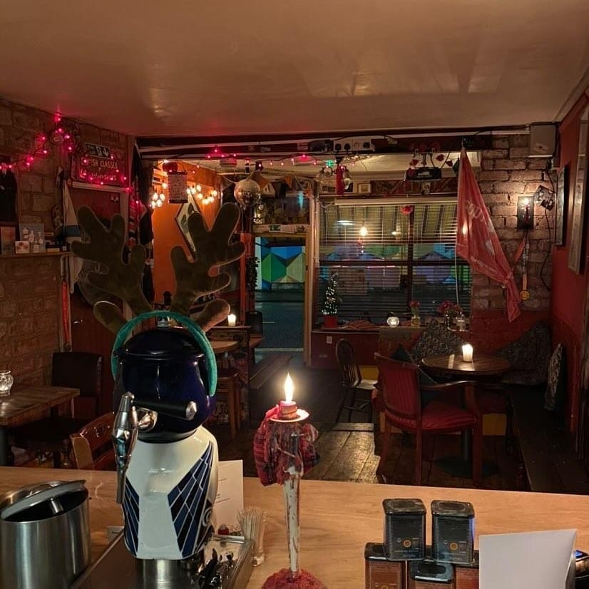
Hiring El Rincon bar for private fiestas
We’re a great little nook for private events, holding up to 40 guests
Private hire with buffet £500.
We ask for a £200 non-returnable deposit, the remainder due 2 weeks before the event
Bar opens at 6pm with last order at 10.30, we ask all guests to leave by 11pm
Live Music
Please speak to us to arrange a live band or DJ, or just a music playlist in the background.
Spanish Buffet includes

A selection of olives, dips and bread, tortillas de patatas, a selection of cured
Spanish Charcuteria,, piquillo peppers, boquerones, Manchego cheese, picos and bread.

Additional dishes for GF, vegan diets etc can be arranged as long as we’re given
sufficient notice
Pre booked entry drinks can be served on arrival, please speak to us about
costs and options.

